# Motherboard: ASUS ROG MAXIMUS IX HERO

By ASUS

ASUS ROG Maximus ix hero is a motherboard manufactured for gaming.

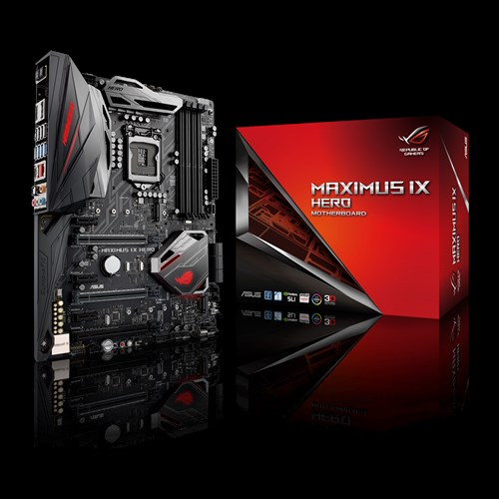

## Expansion Slots

* It is average consumer focused gaming card, so it has only one processor slut.
* There are 4 DIMM 288 pins which means its is supporting DD4. It supports faster rams.

There are different types of PCI Express on the card. **2 x PCIe 3.0 x16**, **1 x PCIe 3.0 x16 (x2 mode)** and **3 x PCIe 3.0 x1.**

## StoRage

* It allows different types of raids such a RAID 0, RAID 1, RAID 5 and RAID 10 with SATA-600 6x connectors.
  + RAID 10 is combination of disk mirroring and disk striping. There is no parity in raid 10.
* It also allows much faster solid-state drives which connect through PCIe. PCIe 3.0 -connectors: 1 x M.2

## OTHER POrts

* **DisplayPort:** A latest technology for video transmission. It’s capable of transmitting 3,840x2,160px 60fps

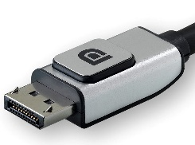

* **HDMI** It is popular technology used for video transmission etc.
* **LAN** (Gigabit Ethernet): It is used to connect to the internet.
* **TOSLINK**
  + It is optical fiber connecter.

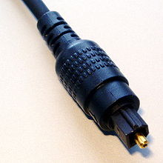

* USB: There are different kinds of USB ports. From USB 2.0/ USB 2.0 / USB 3.0 and USB-C.
* Audio IO ports.

